Task 3

**Opening Issue:**

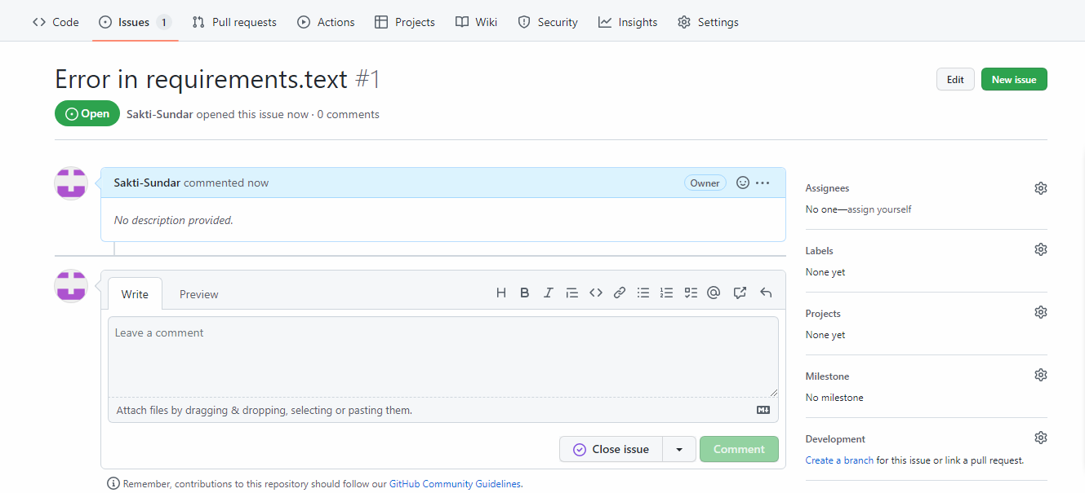

**Open Pull Request:**

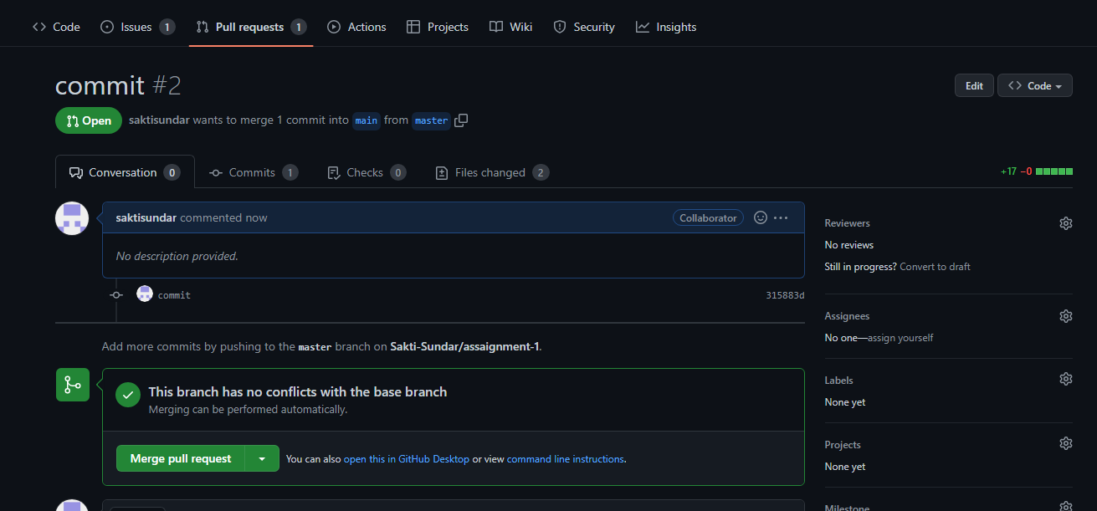

**Rejected:**

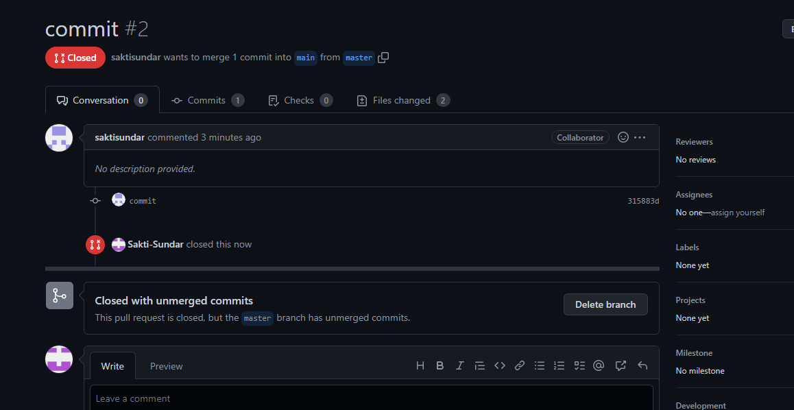

**Merge**

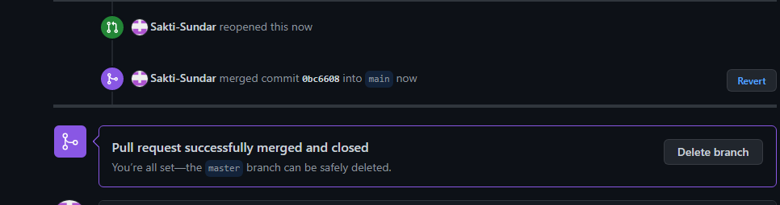

**Added dependabot**

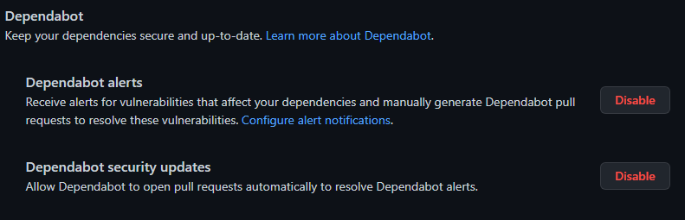

**Stash**



**Releases**

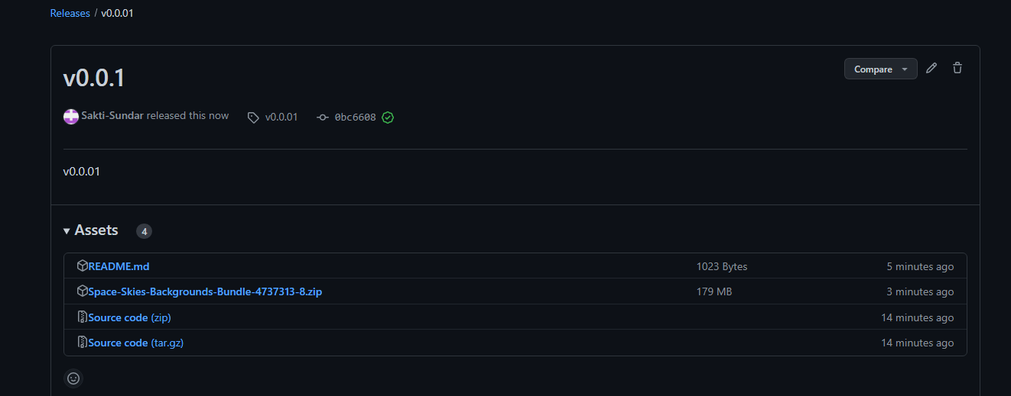

**Projects**

